**Daniel Williamson**

**Project #8**

**4/15/16**

**CS 200**

Project Overview

Purpose:

The purpose of this project was to create a program that arranges user inputted numbers in order from smallest to largest, using Bubble Sort. This is a very simple process, it takes your first value and checks it against the second, determines which one is larger and which one is smaller. If it’s the larger of the two it will move it down the line or keep it where it was. It will then take that same number and check it against the next. Eventually it will find the largest number and it will be all the way at the end of the line. And then it will run all over again. And again. Until, all the largest numbers are at the end of the list.

Approach:

To begin this project, I immediately went to the internet to gain a better understanding of how to program in Assembly, as we needed to create the program using branching and other methods. Also, on how Bubble Sort works. Once I read up, I began to plan how the program should run. As per the structure of assembly I had to begin by declaring all my variables, strings included. I had to create some dummy variables to temporarily hold values until the user inputted them. After that, I started by the main method, which would be using branching to ask the user for input. After getting all the input, it would return address back to the main method and continue on to do the necessary steps in doing bubble sort.

Results

These are my results:

This is where I declared my variables/strings, the dummy variables are simply just temporary

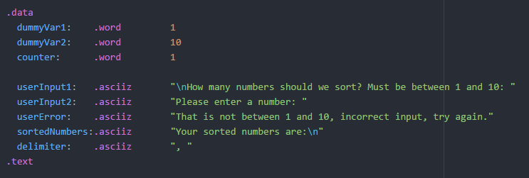

This is my main method, where it keeps track of how the program should be running. Uses branching.

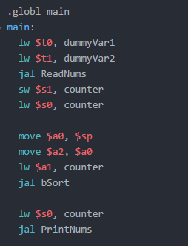

This is the first branch. It reads in the users input. If the user enters an invalid number for how many numbers, the user wants to use. It will jump to countErr and print off a message and jump back to the beginning.

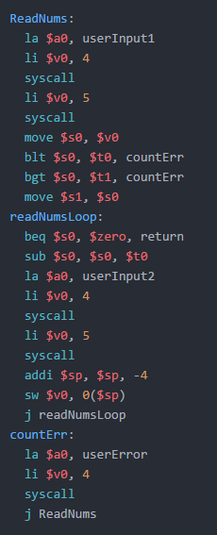

This is where the magic happens and we bubble sort the numbers the user inputted. I referenced a page on StackOverflow for guidance on how to program this.

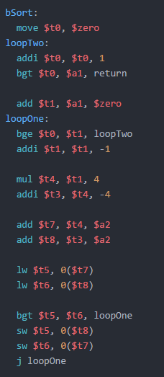

This is where we print off the numbers in order. Also a return address used throughout.

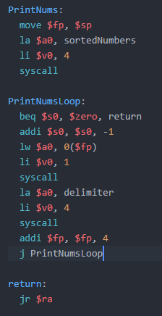

Testing:

This test shows us using 9 random numbers to be bubble sorted.

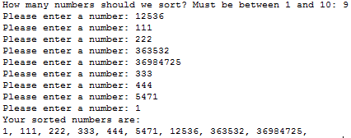

This test shows that entering a negative number still works and makes it the lowest number.

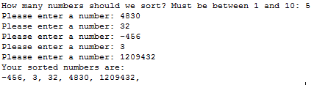

This test shows entering a number less than 1 (0) will through an error message.



This test shows entering a number greater than 10 (11) will through an error message.



Conclusion

In conclusion this has been the most difficult project yet. I am still new to assembly which makes fulfilling your requirements a little more difficult, like separating the program to work in different procedures. However, once I got the hang of things it was rather logical and simplistic. The hardest challenge I faced was just figuring out how to program in assembly.